**Bubble CPAP testing & validation summary** Date: 30-04-2018

**Purpose:**

1. To observe and understand the effect of change in different parameters such as Air Flow Rate, Pressure, Humidity, Temperature of the Bubble CPAP system.
2. The bubble CPAP system uses an oil-based air compressor (for lubrication in the motor). On continuous use, an oil-based system can release particulates. Hence, this test procedure checks the level of gases emitted, and compares emissions with standards.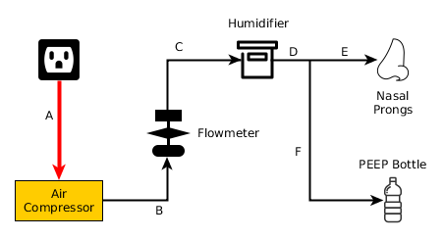

**Materials used in this experiment:**

The test setup consists of the following items.

**1.** Bubble CPAP system including Air compressor, flow-meter, humidifier & PEEP; as shown in Fig.1.

**2.** Arduino Mega 2560 with USB & external power source since the USB port is incapable of providing the power required to drive all the sensors at once. *Fig. 1: System Overview*

**3.** Flat PP sheet with the size of maximum internal area of the humidifier. Later that sheet is to be cut to expose different amount of the water surface area to air to manage humidity in the breathing

circuit.

**4.** Sensor assembly.

The following sensors are deployed in the breathing circuit:

**Gas Sensors:** (For detecting level of concentration of the gases)

MQ-2 **[1]**: detect H2, LPG, CH4, CO, Alcohol, Propane.

MQ-5 **[2]**: detect LPG, Natural gas, Town gas.

MQ-135 **[3]**: detect NH3, C6H6, CO2.

**Temperature & Humidity Sensors:** (For collecting both ambient & relative data)

DHT11 [4]: 16 bit resolution temperature & relative humidity sensor.

**Pressure Measurement:** (For detecting leakage & measuring pressure)

PM-6205 [5]: HTC Instrument Digital Manometer.

**Flow Measurement:**

Dwyer Rate-master [6] flow-meter.

**Test Setup and Methods:**

In this experiment, the following parameters are altered and observed in order to find the relationship between them.

* Flow rate **(1lpm to 10 lpm)**
* Humidifier water level **(1cm to 3cm)**
* Humidifier water surface area
* (**9.5cm x 15.5mm; 0% to 100%;**

to control evaporation rate)

* Pressure level (**1cm to 11cm of H2O**)
* Temperature (**ambient & compressed Air**)
* Humidity (**ambient & compressed Air**)

**Method:**

The following testing environment is set up in order to investigate the amount of potentially harmful gaseous particulates in the air passing through the breathing circuit and also to find out how change in one parameter affects the other . Pressure, Volume/ rate of flow & Humidity level Ambient temperature & humidity is taken under consideration for this experiment.

The CPAP device is set up as shown in Fig 1. Air compressor is connected to a 220 V wall socket. The Flow meter is directly connected to the compressor outlet.

Air flow through the breathing circuit is controlled by a pin valve provided in the flow meter that can deliver flow rates ranging from 1LPM to 10 LPM.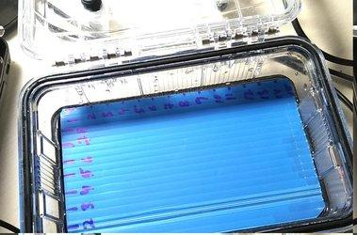

The next component in the breathing circuit is the Humidifier. Since evaporation occurs only on the surface of a liquid, small templates are created using PP sheets that covers certain areas of the water surface. Internal area of the humidifier is approx 9.5cm X 15.5 cm. We have found that the rate of change of humidity is directly proportional to the open surface of the water.

*Fig. 2: Humidifier*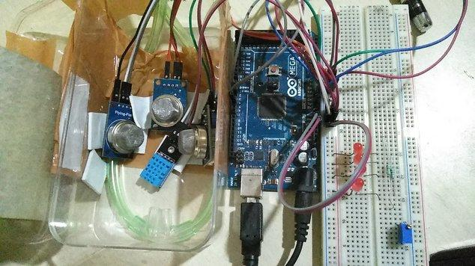

Data is collected using an embedded microcontroller attached to the sensors. The interval between each data point is 3 seconds.

3 pairs of humidity, temperature and gas sensors are deployed at the opening of the nasal prongs to detect the level of heat, moisture & gas concentration at both the ambient & test conditions. Ambient levels are required to calibrate the sensitivity of the sensors.

PEEP bottle has been marked with 0cm to 11cm H2O pressure levels. In this experimental setup the PEEP level is also variable & at each level, the same experiment to be carried out to understand the relation between humidity & gas concentration at

different pressure levels. *Fig. 3: Gas, temperature & humidity sensor*

The data has been collected using a microcontroller platform & sent to the PC using USB communication. A simple python script is written to automatically log it into a spreadsheet. Since there is very limited space in the internal EEPROM of the controller, data has been logged to a spreadsheet using serial programming & Python code. 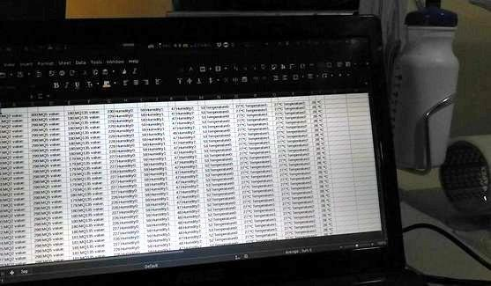

Analogue to Digital conversion values are used to calculate the PPM concentration of the gases.

The following parameters are measured during the testing process.

*Fig. 4: Data logging using python*

**Data & observations:**

In this experimental setup, data is collected while taking time as an independent variable which plotted along the Y axis. A continuous set of 500 data points is logged at every level of flow rate (1 to 10 LPM) while taking all other parameters as constant.

*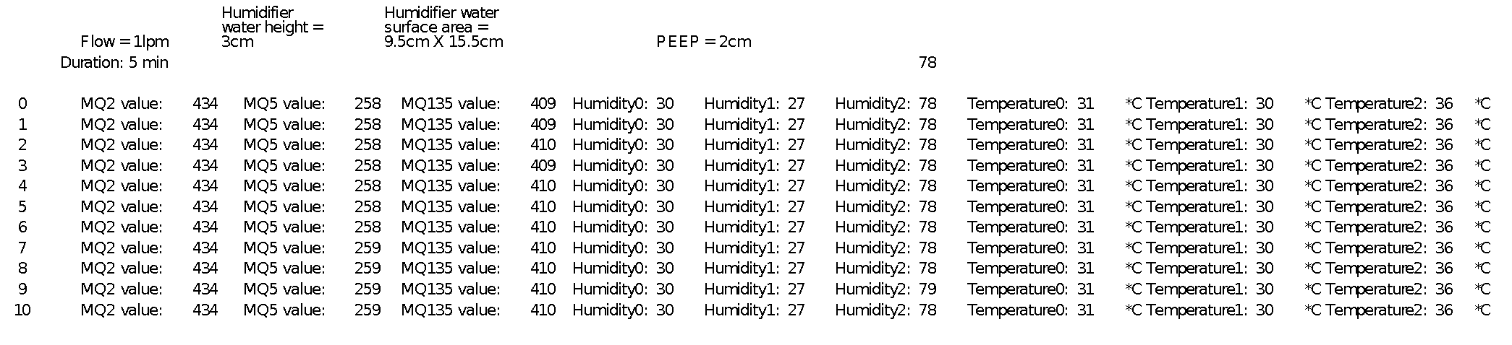Table 1: Variable flow rate at 1 LPM & all other parameters are constant, Independent variable = time*

*Table 2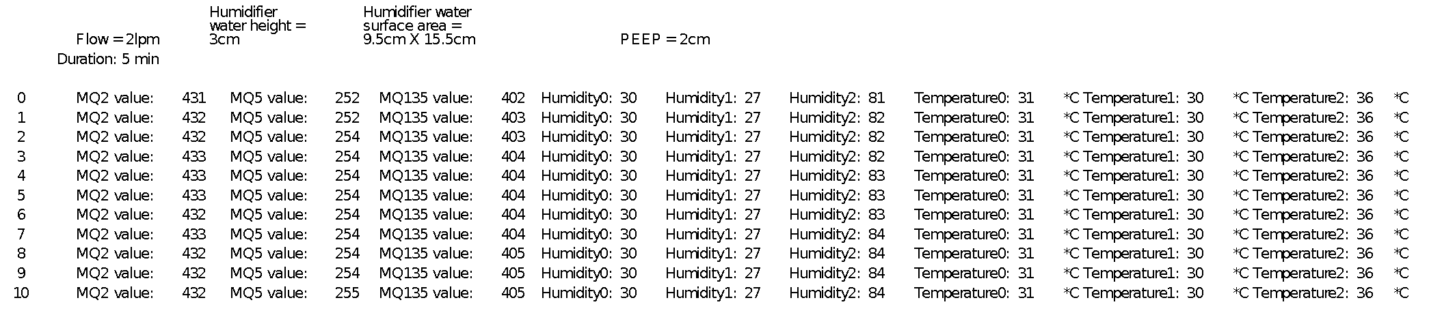: Variable flow rate at 2 LPM & all other parameters are constant, Independent variable = time*

Total 3 sets of DHT11 relative humidity & temperature sensors are deployed in the system for obtaining both ambient & actual humidity & temperature levels in the breathing circuit.

Humidy0 and Humidity1 represents the ambient relative humidity levels

Humidity 2 represents the relative humidity level of the air circulating through the breathing circuit.

Similarly,

Temperature0 & Temperature1 represents the ambient temperature

Temperature2 is the core temperature of the air circulating through the breathing circuit.

The above humidity & temperature readings are required to calibrate the MQ series gas sensors. Datasheet & detailed PPM calculation sheet is attached for reference.

*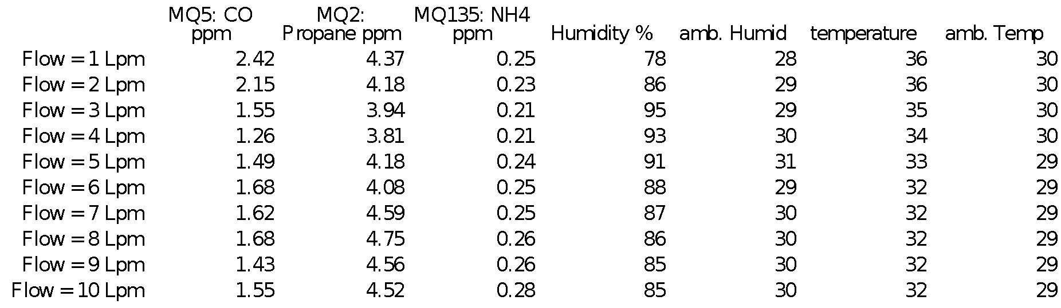Table 3: Gas sensor data, independent variable = flow rate*

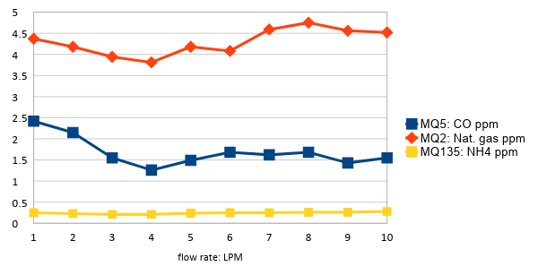

*Plot 1: Gas concentration vs. flow rate plot*

*Plot 2: 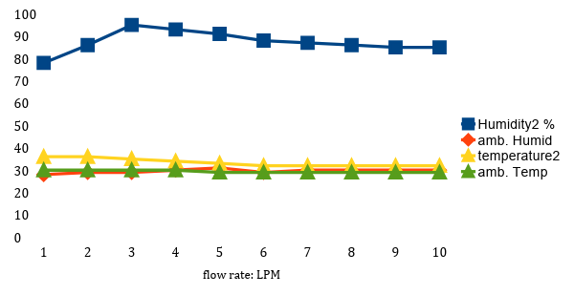Change in humidity w.r.t. flow rate*

The above plot is derived from table1, table2 & related set of data. In table 3, the average of one set of such data represents only one data point. This process can be repeated to get & analyze the entire data set at every flow rate, PEEP & humidifier water column and surface area.

Plot 1 represents the levels of unwanted gaseous impurities in the breathing circuit air. As observed in the experiment, the amount of Carbon monoxide, Propane & related organic compounds & ammonia levels are much below from the safety specifications.

These MQ gas sensors comes with the capability of detecting multiple gases using one sensor, in our experiment only three different gases are mentioned to reduce complexity in the analysis. The whole list of detectable gases & their property curve is explained in detail in the datasheets.

Analog to digital conversion values are obtained from the gas sensors. These PPM values are then calculated using the ADC values & conversion formula.

Safety standards of the mentioned gases:

CO: 10ppm [7]

Propane: 25ppm [8]

Ammonia: 1000ppm [9]

**Observations:**

1. Mounting screws and internal assembly is not affected by continuous 8 hours run for 5 days. The Noise and vibration is not affecting the working of the CPAP device.
2. No significant level of harmful gases in the breathing circuit is found during the test run.
3. Water column height & area is altered to understand the relation between evaporation & humidification levels. Experimental measurements were made with minimal changes (3%) in ambient humidity.
4. Humidity beyond 85% for 2 lpm or higher flow rate, with ambient humidity at 30 +/- 1%.
5. Air compressor dissipates heat during the run. 3 temperature sensors are deployed; 2 for ambient & 1 at the outlet of the nasal prong to understand the rise of air temperature through the breathing circuit. Maximum temperature elevation is 6 degrees Celsius, with ambient temperature ranging from 29 to 30 degrees Celsius.
6. These results have been obtained in low ambient humidity (28-31% RH).

**Inference:**

1. The system delivers 80% or higher relative humidity, without saturating air. This is an ideal zone of operation, since it delivers moist air to babies, without risking irritation caused by saturated air that condenses and “spits”.
2. Ambient temperature and humidity are comparable to fields conditions in Uganda in summer.
3. The expected working range of this system is 4-6 lpm; in this zone, the system delivers consistent humidity and temperature.

**Additional Work:**

Leakage detection in the breathing circuit, pressure difference at different points of the circuit etc. to be verified.

The above experiment Carbon & Nitrogen based gases & their derivatives. A more robust & calibrated gas sensing technique [10] [11] can be adopted to identify the exact gases, oil & particles in the breathing circuit.

One most important part of the testing is to identify the microbial contamination in the system. [12]

**Appendix**

1. MQ2 Datasheet:

<https://www.pololu.com/file/0J309/MQ2.pdf>

2. MQ5 Datasheet:

<https://www.parallax.com/sites/default/files/downloads/605-00009-MQ-5-Datasheet.pdf>

3. MQ135 Datasheet:

<https://www.olimex.com/Products/Components/Sensors/SNS-MQ135/resources/SNS-MQ135.pdf>

4. DHT11 Datasheet:

<https://www.mouser.com/ds/2/758/DHT11-Technical-Data-Sheet-Translated-Version-1143054.pdf>

5. PM-6205 Datasheet:

<http://htcinstruments.com/images/PM-6102-6105-6115-6130-6175-6202-6205-1.pdf>

6. Dwer Flow master Datasheet:

<https://www.itm.com/pdfs/cache/www.itm.com/dwyer/flow_meter/rm_series/datasheet/dwyer_rm_series_flow_meter_datasheet.pdf>

7. Carbon Monoxide safe levels

<http://airtesting.com/wp-content/uploads/2017/04/Breathing-Air-Specifications-2017-2.pdf>

8. Propane & related gases safe levels

<https://www.ncbi.nlm.nih.gov/books/NBK201461/> paragraph. 2.2.2

9. Ammonia safe levels

<https://www.airgas.com/msds/001003.pdf> p.5, sec.8

10. <https://www.airbestpractices.com/standards/food-grade-air/sampling-and-testing-compressed-air-contaminants>

11. <https://www.airchecklab.com/services/manufacturing-iso-8573-1/>

12. <https://www.ncbi.nlm.nih.gov/pmc/articles/PMC2556912/>